Operators and Integers

Look at this code:
num1 = 12
num2 = int(input("Enter a number between 1 and 12: "))
total = num1 * num2
print(total + 3)

Write down exactly what you think this code will do:
Click or tap here to enter text.

Run the code! Were you correct?
Click or tap here to enter text.

Let’s investigate! Answer the questions below:
- If I enter 6, which number is stored with the name num2?
Click or tap here to enter text.

- After num1 is multiplied by num2, which number is stored with the name total?
Click or tap here to enter text.

- What number appears on screen when the program finishes?
Click or tap here to enter text.

Operators and Integers

Look at this code:
num1 = 12
num2 = int(input("Enter a number between 1 and 12: "))
total = num1 * num2
print(total + 3)

Use the code above to help you. After completing each challenge below, run your program to test that it works correctly. Save each completed challenge program in a new file.

Programming Challenges

Challenge 1
Ask for two whole numbers, convert both with int(), and display their sum.
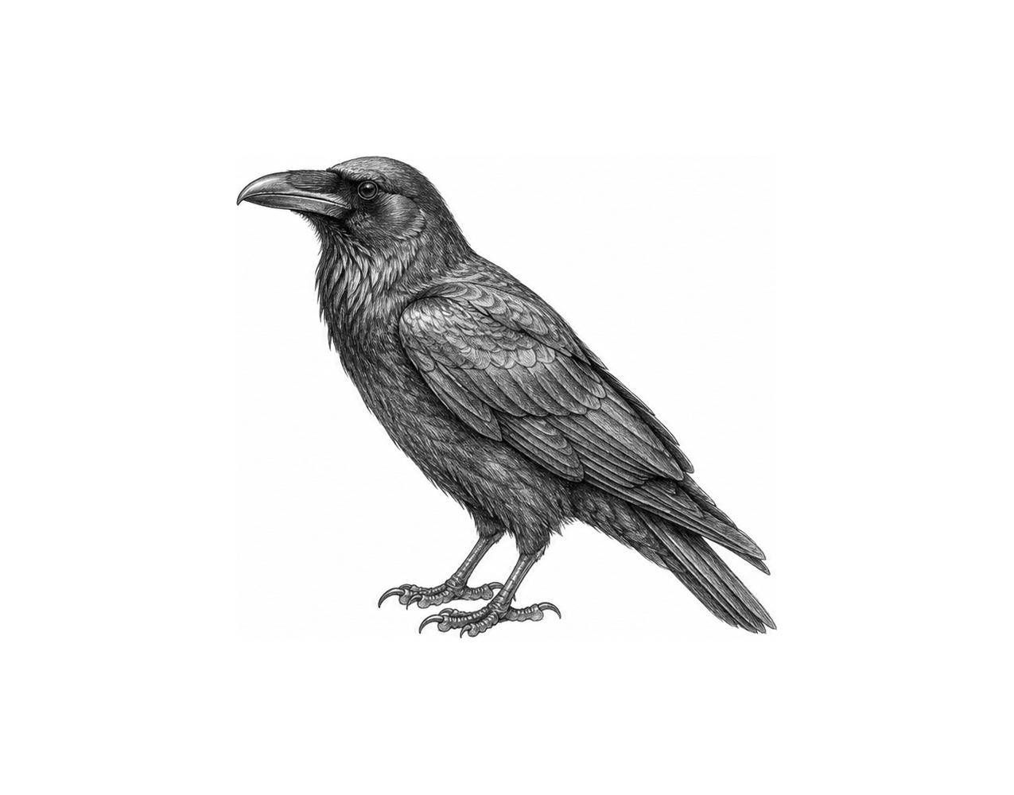

Challenge 2
Store 2 as a non-zero secret number, divide the user's sum by it, and display the new total.

Challenge 3
Create a program that asks for three whole numbers, subtracts the second and third from the first, and displays the total.

Operators and Integers

Fix the code!

This code has errors! Look closely at the code to find the problems:

num1 = ("12")
num1 = int(input("Enter a number between 1 and 12: "))
input(num1 * num2 - num1)

Rewrite the whole program in the box below with fixes to the errors.
Click or tap here to enter text.

After you are confident that you fixed all the errors, copy the code from the box and run it.

Did it work correctly on your first try? Did you find all the errors?
Click or tap here to enter text.

